**Data Analyse of Banknote Dataset**

The main purpose of the research was to create a model by which fake banknotes could be found. The data was taken from Dataset, which is freely available on the Openml website. It scanned about 1400 bills and gave all the data. The data were studied using statistical methods and examples (for example, finding moda, mean and standard deviation).

Moda

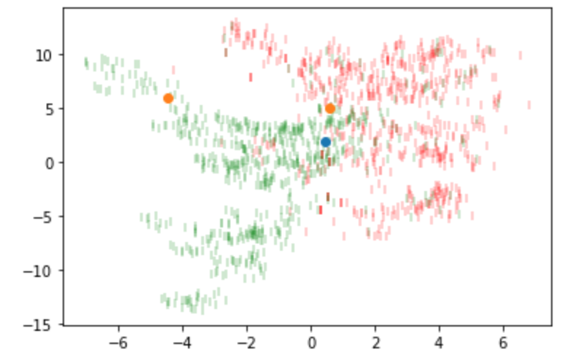Mean

In addition, the analysis of standard deviation was carried out and it is depicted on the graph in the form of an elips

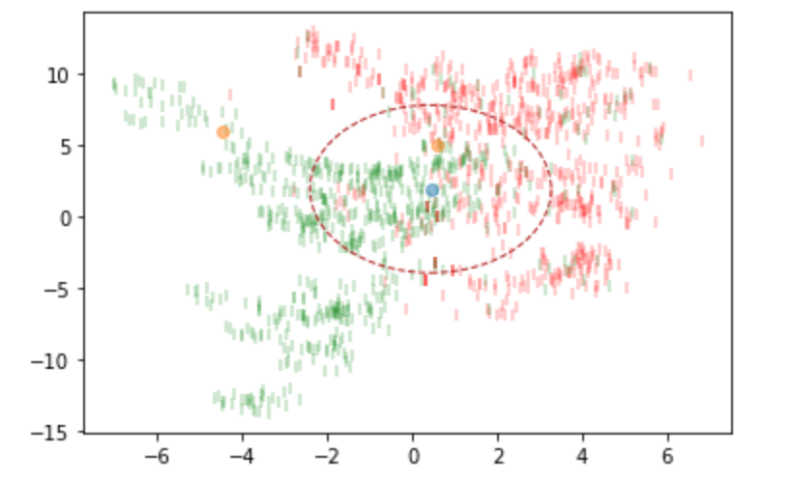

The cluster method was also used. And checked several times showing the approximate results in 8 cases out of 10.

Clusters

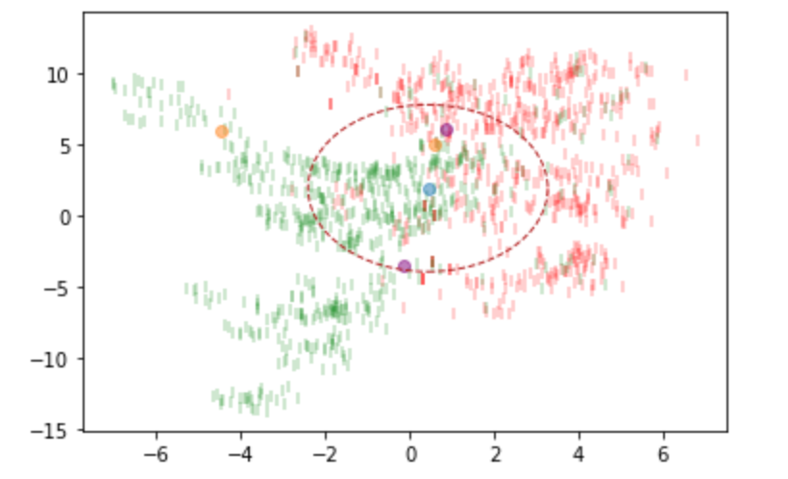

The main recommendations will be to optimize and improve the understanding of the given data. Also, to use this method for the finding of fake banknotes and the introduction of this method into the product